Summer Reading

ALL NINTH AND TEN GRADERS WILL READ THIS TEXT

Required Text: *The Cat Who Saved Books* by Sosuke Natskukawa (ISBN 9780063095731)

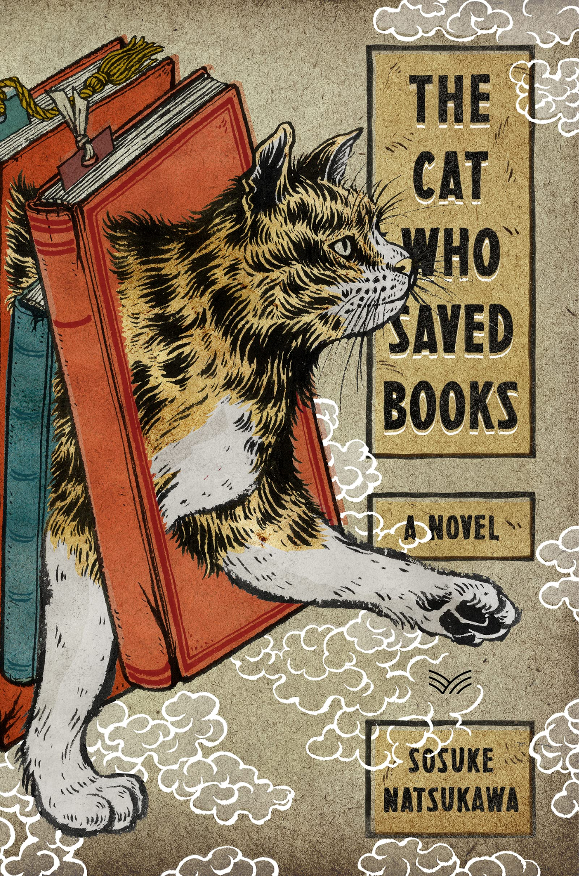

Over the summer, please take the time to read and enjoy *The Cat Who Saved Books*. When you begin classes in the fall, there will be an in-class writing assignment during the first week of school. Below are some guiding questions to think about as you read. The goal of these questions is to help you think about important questions and to guide you as you read. **These are not to be formally completed and turned in.**

Vocab to know:

**Hikikomori** - A Japanese term for a young, quiet, and shy person.

**Labyrinth** - Throughout the story, Rintaro goes on various adventures, or quests, with the cat. The book refers to these adventures as “labyrinths”. These are magical challenges or “tests” Rintaro must face to learn more about himself.

1. Throughout the book Rintaro is described as a “hikikomori”. What are some characteristics you notice about Rintaro at the beginning of the book? How does he seem to view himself?
2. Rintaro was very close with his grandpa. How does his grief over his grandfather’s death influence his sense of self at the beginning of the story, and how does this change over the course of the story?
3. Throughout the book, Rintaro’s relationships with his friend Sayo and the cat play a major role in shaping his identity and helping him grow. Reflect on how his interactions with others help him become a more courageous and self fulfilled person.
4. In the final labyrinth, Rintaro is told by the cat that he must complete it alone in order to save his friend. What does it reveal about his growth as a person that he chooses to go through with it - despite going alone? Would Rintaro, at the beginning of the book, have made the same choice? Explain your reasoning.
5. Empathy is the ability to understand and share the feelings of others. Reflect on Rintaro’s discovery in the final labyrinth about empathy. What role did empathy play in Rintaro’s journey to save books, his friend, and help him figure out who he really is?